*6/7 PM Real news vs fake New Blog*

(title) Real News vs. Fake News: How can you tell?

(h1) Can YOU Tell the Difference Between Real News and Fake News?

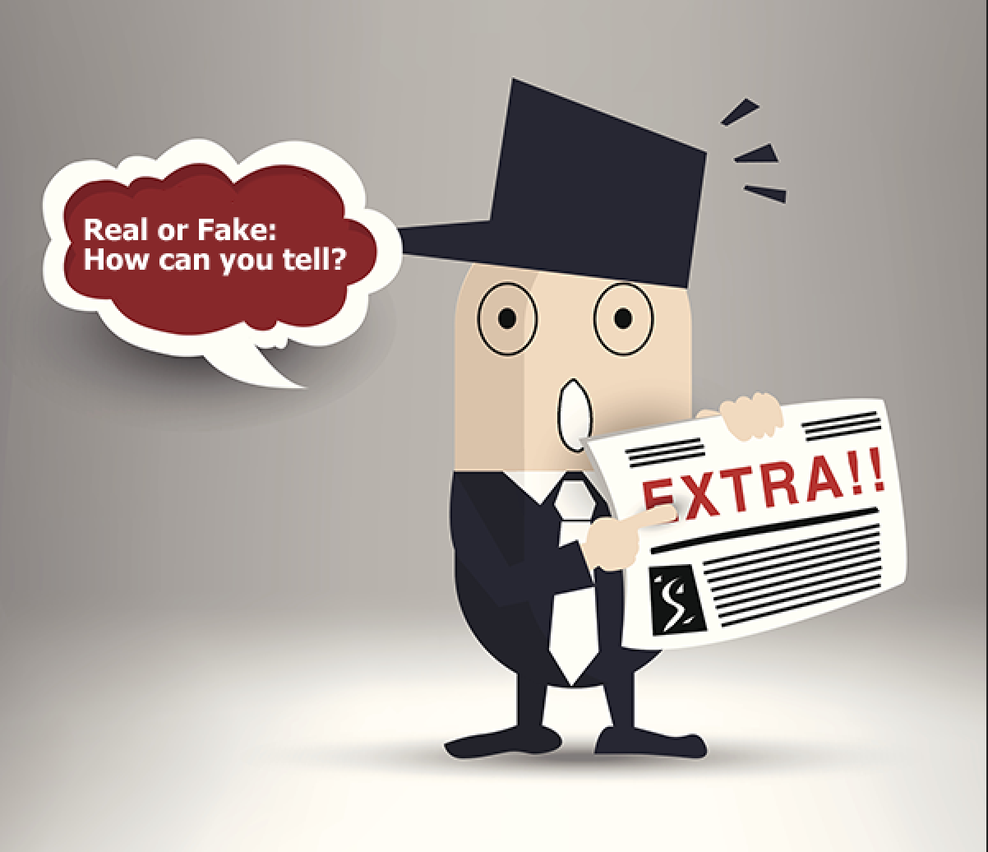

[alt text: Real news or FAKE? How can you tell?

It’s the millennium. The age where self-proclaimed blogs and technology are plentiful, and social media outlets like facebook and twitter are communal feeding grounds for pop-culturalists and newsies alike. Today anyone with an opinion and a cell phone can post “news” stories online. But who’s to say what’s real and what’s fake news? [http://blog.pch.com/blog/2016/07/20/winnerwednesday-real-people-win-pch-prizes/]

With so much content out there, we want to make sure that when it comes to Publishers Clearing House news and announcements, you can – without a doubt – tell fact from fiction. And, what better way to jump into the murky waters of *real vs.* *fake news*, than to put your own PCH knowledge to the test!

(h2) Quiz Time: Can you tell which headlines below are REAL news and which are FAKE?

#1: No Winner, No Check?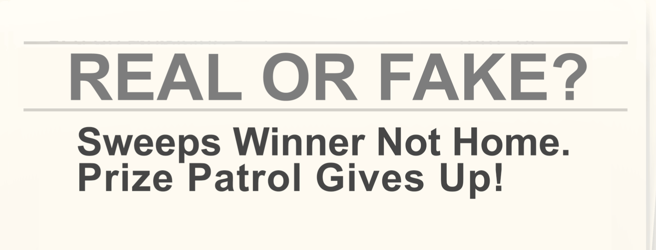

[alt text: REAL OF FAKE: Sweeps Winner Not Home. Prize Patrol Gives Up!]

**FAKE NEWS!**

No way this is true! The PCH Prize Patrol always finds our winner, even if that means delivering the “big check” on a plane ride to New York [http://blog.pch.com/blog/2016/03/31/know-prize-patrol-found-winner-plane/

] (yes, that really happened).

#2: A Call to Collect? 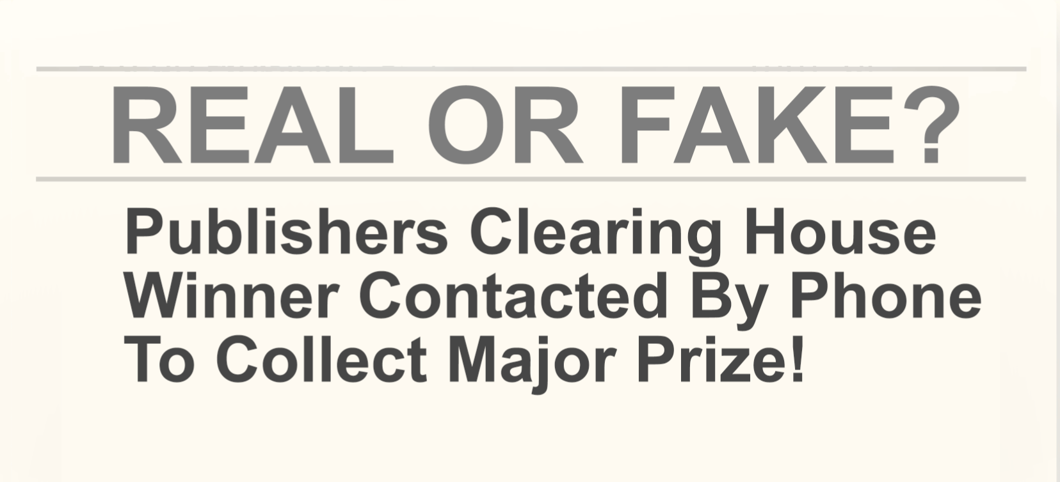

[Alt Text: PCH Winner Contacted by Phone to Collect Major Prize!]

**FAKE NEWS!**

We’ll NEVER tell a major prize winner before award day that they won – and certainly not by phone (that’s a scam alert) [http://blog.pch.com/blog/2017/05/11/sweepstakes-scam-alert-accidentally-helping-scammers/]. It’s just not our style. We like to surprise our winner on award day in person with a big smile and a very big check.

#3: Losing State?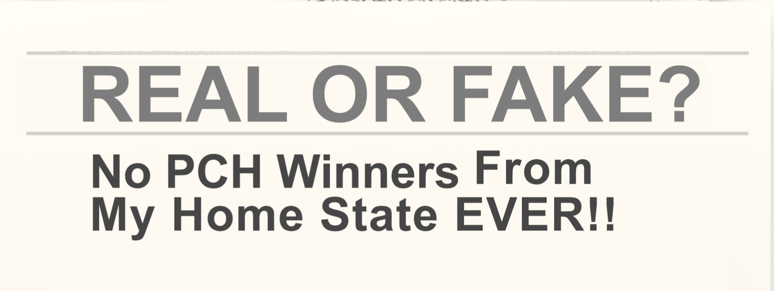

[Alt text: No PCH Winners From My State EVER!]

**FAKE NEWS!**

No way - you can bet we’ve had winners from your home state! In fact, over $327 Million has been awarded to date with winners in ALL 50 STATES [http://blog.pch.com/blog/2017/05/15/pch-winners-can-live-wherever/] – including yours -- plus Canada and the Yukon, too! That’s a lot of winning.

#4: June 30th Event?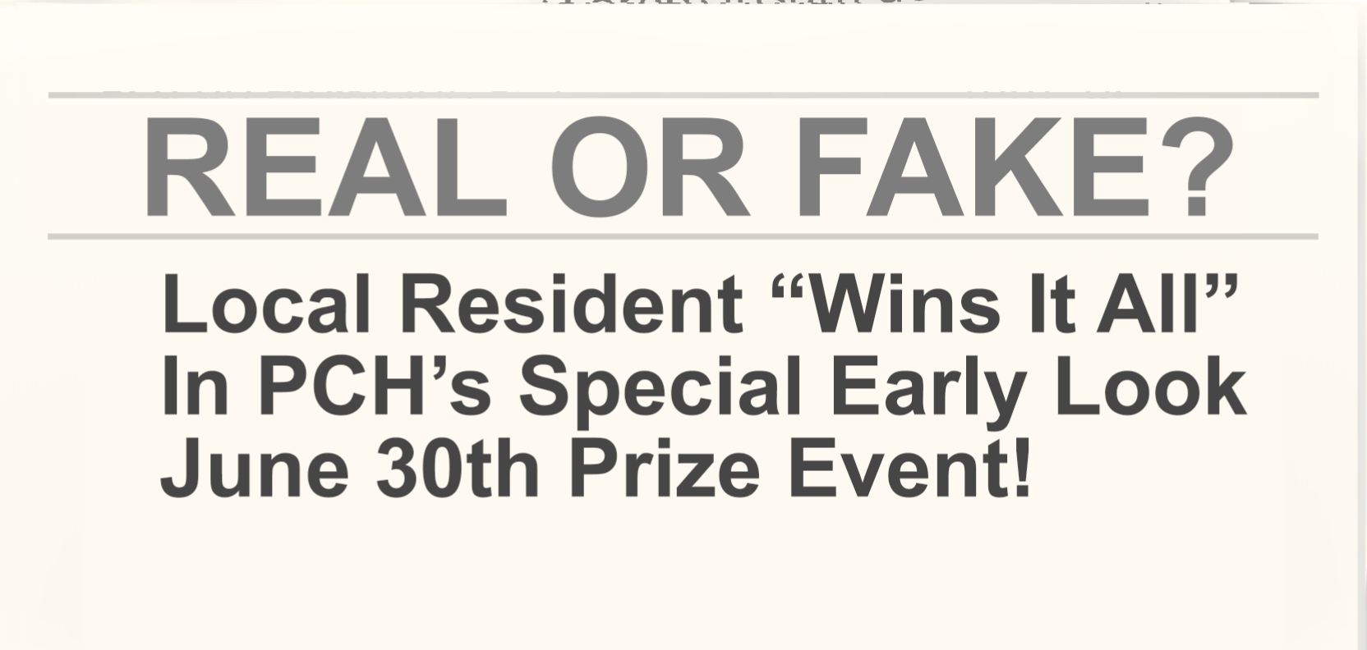

[Alt text: Local Resident ‘Wins It All’ in PCH’s Special Early Look June 30th Prize Event!]

**REAL NEWS!**

Absolutely! The next big prize we’re prepared to award is the multimillion-dollar “Win It All” prize [http://blog.pch.com/blog/2017/05/18/life-change-win/] – that’s a $2 Million lump-sum, plus $10,000 A Month For Life, plus a New Lincoln MKZ valued at $36,095 – and we could be heading to your area. Have you entered to win today? [http://pch.com/]

So, how did you do? I’m sure as a dedicated fan, you already knew most of those answers, BUT if you didn’t and you learned one new PCH fact today, then pat yourself on the back because you just fired a flaming truth sword into the belly of the fake news beast! It felt good, right?

Great job! Now, make sure you enter to “Win It All” today before time runs out. [http://pch.com/]

Nicole T.

Online Creative

P.S. We have REAL WINNERS every day! Tell us below how you would make YOUR Winning Moment exciting on June 30th!

Similar posts you may enjoy:

#WinnerWednesday: Real PCH Winners Enter In All Kinds Of Ways!

[http://blog.pch.com/blog/2016/06/22/winnerwednesday-real-pch-winners-enter-kinds-ways/]

PCH Sweepstakes Winners Help Answer The Question “Is PCH Real?”

[http://blog.pch.com/blog/2016/05/23/pch-sweepstakes-winners-help-answer-question-pch-real/]

Let’s Count All The Ways To Enter To “Win It All”!

[http://blog.pch.com/blog/2017/05/17/lets-count-ways-enter-win/]

Keywords:

Real news vs. fake news, PCH, social media

Meta-Description:

Real News vs. Fake News: Can you tell the difference? Don’t get scammed by Publishers Clearing House scammers. You’ll want to read this!